
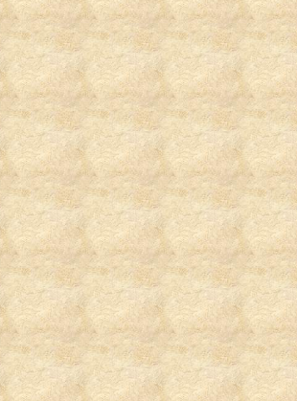

Miriam S. Stevens, Senior Editor

The last couple of years have been a trip for me…a voyage of unknown proportions. At the end of 2007 when I said to the Lord “I want to have Life and THAT LIFE more abundantly regardless of what it takes”, If I had known then the kind of ride that followed, and what I was going to experience; I might have thought twice before I said that to the Father (haha). I have had my ups and downs before in my many years of being a single Christian lady raising my family alone. I have experienced rough journeys before singlehandedly raising my son through the public school system, keeping him out of street life, and making sure we kept a roof over our heads. It is a challenge being a single mom as I am sure a whole lot of persons are now saying, ”AMEN to that sister”. Not only do we have a lot of single moms out there, but there has been an increasing number of single dads raising the children by themselves void of the mothers presence. Yet, when I longed for a different life, one without the fear of poverty, homelessness and lack; and cried out to the Lord saying you promised me that I could have life and that life more abundantly, I never knew how this plea would change my life as I knew it. As the saying goes, ‘if you want something different you have to do something different’ really rang true for my life.
In the middle of 2008 I suffered unemployment. But the worst came in the ending of that year, October 24, 2008, when my life was threatened and almost ended. Well, praise the Lord, for God said “no you can’t have her “and so I was spared. I never thought my life would have ever experienced such a tragedy. Yet, my story isn’t unique even though it’s real to me and has impacted my walk with the Lord. In
2009 I had to deal with lingering demons from the harrowing experiences of 2008. All through this journey the Lord kept me and my family. Even when I couldn’t deal and felt like I was slowly slipping into nothingness; the Lord said I would never leave you or forsake you. Even when others couldn’t understand the depth of my depression and fears; the Lord was still there in the hell that I lived. The scripture - if you make your bed in hell, I would be there with you - became my mantra. Through all of this death that surrounded me, a funny thing happened; I began to experience a new birth. I began to see the glimmer of hope shining through the dark cave that I had buried myself away in to escape my agony. Somehow, my God through His loving caressing ways, found me when no one else could find me and began rebuilding me. From the inside out, He began this rebirth process and truly the ringing of… ‘you are my workmanship’,’ you have a future hoped for’, ‘He who the son has set free is free indeed’… began to be the new meditation of my thoughts. Those demons of fear, doubt and despair started to be excavated and ushered into my mind was liberty, joy, peace and hope. I started to breathe again and experience a change in my existence that resembled a flower in bloom. I started to have a wellspring of passions flood out of my being to overflowing.
My current circumstance from the “outsider” looking in hasn’t changed. I am still unemployed, I am still a single parent with all of the challenges to maintain a semblance of life, and I still have some debts to pay. Yet, what God breathed into my body the day I laid on my bedroom floor dying, was what I pleaded with Him to have: Life and That Life MORE ABUNDANTLY. That was the defining moment where the true change occurred; as old things passed away and behold all things are new. Now, I taste and see how good the Lord truly is. I thought that the Lord and I had a good relationship before; but now, it’s out of this world – literally. I am no longer chained to the “world’s way” of dealing with life and life situations. I have a new lease on life hungering and thirsting after righteousness.
It seems like the passions of my youth have been reinitiated. I am flowing more in the gifts that I thought had died. Maybe it took a literal death of me to bring forth new life.
The word does speak about a kernel of corn dying and I truly identify with how out of death there is resurrection life to ascend to the Father’s throne and abide forevermore. My heart’s desire has been to be more like the Lord in my heart, mind, spirit, and body. Living for the Lord now is new every day. No more humdrums and blues, but now filled with unimaginable expectations. I realized how great living life really is and to not take any day for granted. Truly we don’t know when our last day on this earth will be but as long as we have breath in our bodies we can make every moment count. Our life counts even when we feel we have nothing to offer we can be an agent of change. We can start with ourselves and then make an impact on all others around us. It is the ripple effect, like a stone being thrown into the water and then the impact of that stone hitting the water is visibly seen right before our eyes. When I was thrown in the water of life drowning with the cares of life; facing a personal tragedy; I woke out of darkness into His marvelous light of life. I rose to the surface. I did not drown but became ripples for others to visibly see. I am so grateful to the Lord for His grace, mercy and goodness. I am so longing to unveil more of Him. I want to learn more about His ways and life. I desire to read and reread and then read again His word. I am so excited when I get a Rhema revelation on just one word spoken to me. I laugh at the “being set up” moments that God puts me through because it’s all for a “good end and preplanned future He created for my prosperity.” I now feel like an eagle soaring to new realms in an atmosphere only reserved for the presence of the Lord flyers (smile).
The Lord is awesome and has so many treasures for us to find when we diligently seek to know more of Him. This is my desire and this is my life’s purpose and the reason why I was born and why my life was spared that October morning. To know more of

More of Him in 2010

Below is an inspirational piece I wrote recently as I am getting to know more of the lover of my soul, protector of my body and restorer of my life. Entitled “Even in The Midst”
Copyright ©2009 by Miriam S. Stevens aka Essence of Myrrh Proverbs 3:5-7
Even in The Midst
by Miriam S. Stevens aka Essence of Myrrh * Proverbs 3:5-7
Have you ever asked; “Why bad things happen to good people?”.....

We all have things that happen in our lives wishing it never passed through our door, like the times of the grief when loved ones pass away. The spouses who leave and say I just don’t want this and throws up their hands saying No More...Even in the midst when tears are streaming down your face, even in the midst when wounds have pierced your inner core, even in the midst when you can't see the light at the end of the tunnel....there is a word from God that says ‘All Things will work out for our good’.

When you think no one cares about you, and your family spits in your face, the way of this world says you're not worth loving because size three you've never claimed. The pain and torment of constant ridicule just hoping comfort would come your way. Even in the midst of haters saying you're nothing, I will prevail.

The child, who is scared of the darkness that haunts in night, wishing you never existed. As a child we learn to hide the daily beating episodes...we go to school afraid to say a word, smiling while in pain, masking the secret which is carried through the family bloodline fearing exposure would reveal the awful shame… and So in silence another voice muted from the liberty to sing a new song of hope and joy. The cells in your body no longer respond to chemo, the last stage of life as we know it. Often times we ask...why God do I suffer, not understanding we don't have all the pieces of the puzzle. Our final strength is used to lift our heads, giving comfort to the loved ones we leave behind. We encourage them to go on with life knowing all the dreams we planned will be no more. Even in the midst when times of trials are at its greatest, even in the midst when all have walked away. Even in the midst when our questions seem never to get answered.....I still say, nevertheless I will give you praise.
In the middle of the journey on the road that I am walking, I do not forsake your word Lord that I will survive and I will choose Life. So, even in the midst I will trust you Lord regardless of the trial, even in the midst I will to will my mouth to give you praise, Even in the midst I know that I am more than a conqueror and I will prevail because what is meant for bad you've made it good.

When our home has been foreclosed and our family walked away; sometimes the needles become our closest friend...or maybe the choice is a gun contemplation ending the hurt and this solution becomes our best friend. We face identity crisis, unpaid bills and homeless degradation; we face closed door employment, senseless crimes between brothers, religious atrocities, But even in the midst of endless life oppression there’s an answer and I will praise your name. Yes there's another choice...because…
Even through a weary walk when all my strength has left me and I know your hand has never left my side and your word has always been the voice I have heard since I was a child , I trust you Lord, I give you praise, I know I will prevail. Selah - Shalom
Copyright©2009 by Miriam S. Stevens
Him and develop our lifelong relationship is the passion of my new life. To bask in His presence and enjoy all the benefits of just being loved by Him is my primary pleasure for living now. All too often we purchase materials seeking out why we were born, or how to find our purpose, and what do we need to do to obtain our divine destiny. I am finding out for me to really have life more abundantly, even in the midst of tragedy, circumstances and trials; what really counts is my effort to walk in obedience, be faithful to His word, and worship the Lord in spirit and in truth. All I need to do is appreciate that God loves me regardless of who does or doesn’t love me. All I have running through my veins is a blood bought covenant that Jesus died so that I could live. All that really matters is the choice I made to dedicate the life I have here on planet Earth to be God’s. I have a joy in my life that I have never known before in all of my previous 44 years of living. To know that I am in this world, but not of this world; and that I am an heir to my Father’s Kingdom is life changing in itself. It just blows my mind realizing that on my deathbed I journeyed like my Savior, Jesus; to hell and back with the keys and authority to the kingdom and victory over death and hell. To God I give Him all the glory and honor and praise! He is an awesome lover. One that has brought me into an ecstasy never felt in my natural or spiritual body before. God is truly the best lover EVER! To be with Him here on earth as it is in heaven, is the longing I have now. And the Lord is never one to let me down in fulfilling ALL of my needs! Establishing God’s kingdom here in and through me in all the humbling circumstances that I face; is my heart’s sole desire. I rejoice everyday… waking up saying I love you Lord, and thank you for another moment to know MORE of you. Selah

Senior Editor/ Exhortation
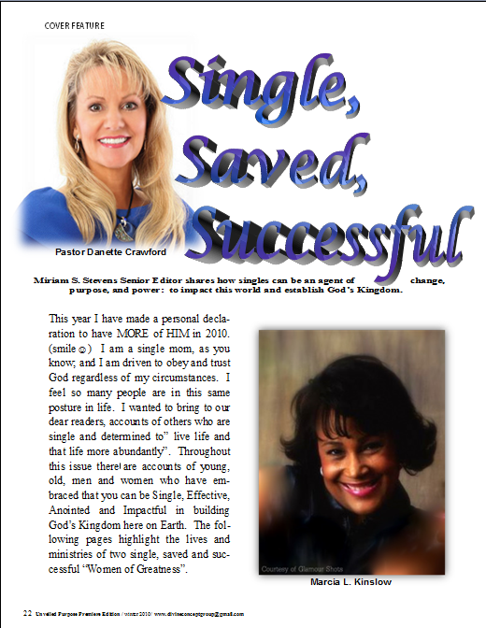
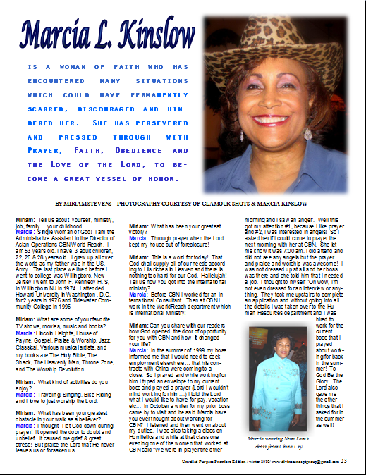
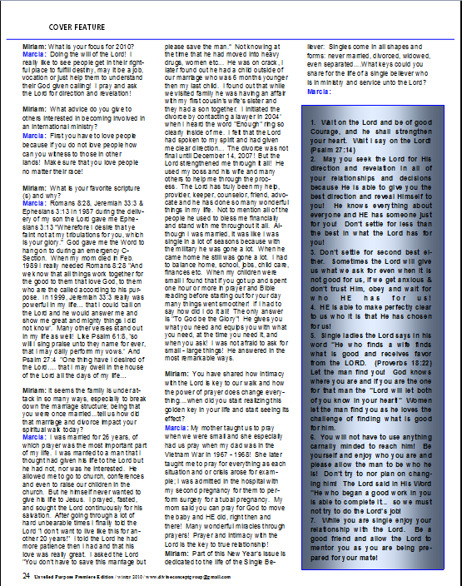
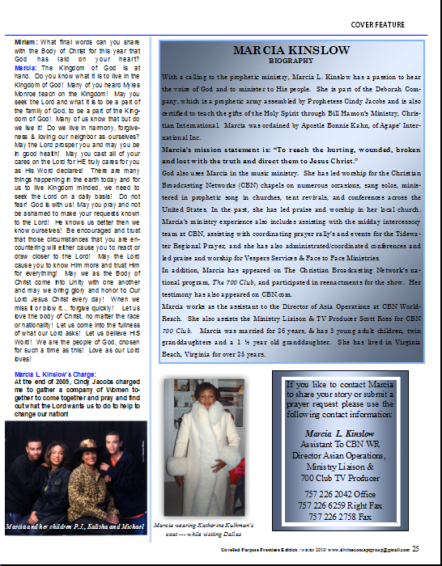
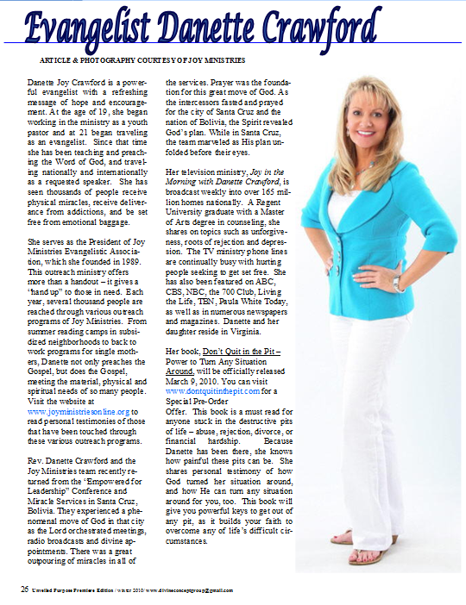
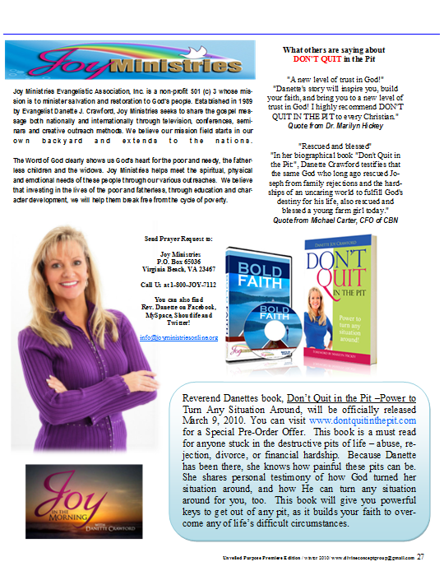
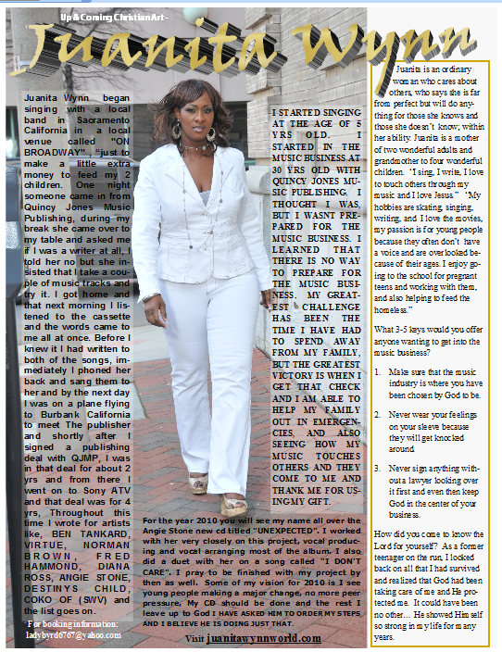
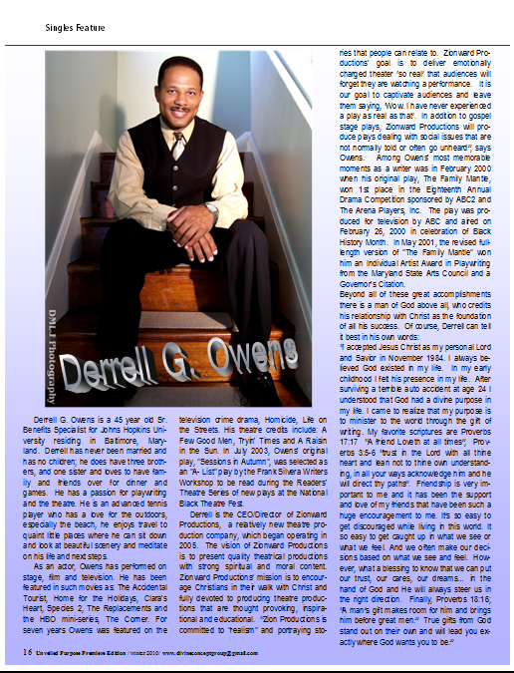
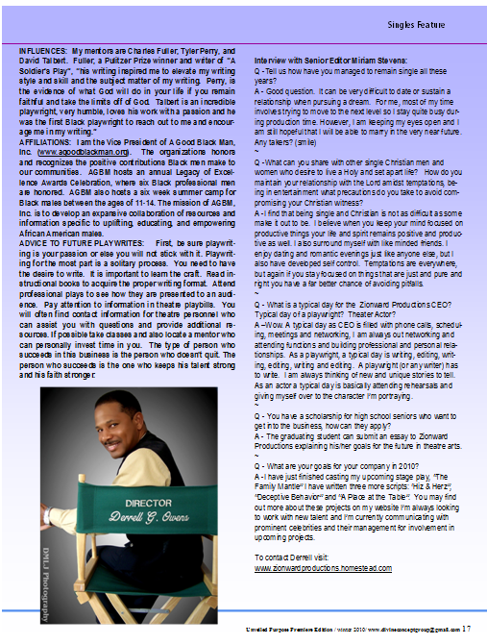
Story by Miriam Stevens

