WHAT IS THE BENEFIT OF TRUST? (Part Two) By

Miriam S. Stevens, a.k.a. “Essence of Myrrh”

Review in Word Document this message by clicking on the following link: TRUST Part One a Word from God written on 11.26.17 by Miriam S Stevens aka Essence of Myrrh
You can also review on our website the complete post: Part One of What Is The Benefit of TRUST? (Part One)

HOW DO WE TRUST?
T = Trust the Promise/Take hold of God’s Word
R = Remain in Peace/Rest in the Pace
U = Unbelief instills Panic/Uninstall Deceitful Poison
S = Strengthen your Posture/Stand in Faith
T = Totally Fulfill Your Purpose/Time is N.O.W. to live Free & Abundantly
We are commissioned to be people of faith and obedience. The mantle of the Lord is upon us so that we can fully realize all the benefits of a divine relationship. When we rely unashamedly on what God says and ignore wholeheartedly on our own feelings, fears, and facts; then we will soar to the height of worship and liberty that only total T.R.U.S.T. breeds.
Let’s make this declaration to T.R.U.S.T. God in our journey. This means to grasp His Word, remain in peace while enduring your journey, unpack all negativity from our minds, steadfastly stand in faith, and then totally realize your purpose if you continue to T.R.U.S.T.
In Part One we explored the importance of taking hold of God’s word to endure through every scenario faced in our life. We must not waiver when we believe that what God said is truth. This allows us to usher in the Peace of God that surpasses our own understanding. With that said, let’s move into the second level of our T.R.U.S.T. journey.

CORE SCRIPTURE:

Philippians 4:7 English Standard Version (ESV)
“And the peace of God, which surpasses all understanding, will guard your hearts and your minds in Christ Jesus.”
R = REMAIN IN PEACE/REST IN THE PACE
Previously, The Thankful Revolution explored the topic to have Peace in the Pace, and this message solidifies that we must stand fast to God’s word while amid chaos. This type of posture allows us to take hold of peace while in the pace (journey) and path of life. While meditating on the benefit of peace, I reviewed an online article from Ngozi that provides 8 Benefits of the Peace of God. I want to share these and provide additional insight into why when we T.R.U.S.T. God how Peace in the Pace and deciding to Remain in Peace breeds abundant benefits to the believer.
Ngozi shared the following as 8 benefits for Peace of God:
- Good Health
- Positive Mindset
- Hope
- Build and Fortify Relationships
- Better Working Environment
- Creativity
- Satisfaction and Contentment
- Favour
First, peace does allow our bodies to remain in good health. Stress is a killer of peace and when we are overly stressed, we start to develop internal problems in our bodies that leads to external ailments to manifest to often bodily decay and demise. A key scripture that affirms that God desires us to enjoy life and that life more abundant with peace is identified in Jeremiah 33:5 (NIV), “‘Nevertheless, I will bring health and healing to it; I will heal my people and will let them enjoy abundant peace and security.” When we decide diffuse internal stress and release anxieties that bog us down, we can enjoy peace regardless of circumstances. Peace allows our bodies to be strong, healthy, and resilient without the decay that dwelling in stress can cause. We are commanded to think on pure thoughts that are based on God’s principles and this type of thinking dismisses dwelling on stressful situations. Stress can produce a breakdown of our internal bodies mechanisms to fight off disease. Our body’s immune system can become compromised when we do not release stress. If we do not allow peace to remain in the forefront of how we decide to live, we enter the realm of chronic stress related disease, aches, ailments, and ultimately premature death. Even in this day and age, there are some who are of the opinion that stress is killing at a more rapid rate. Whether it’s man’s opinion or not, God’s word declares that He gives us peace to live life and that life more abundant because He has already declared for us to live as victors. 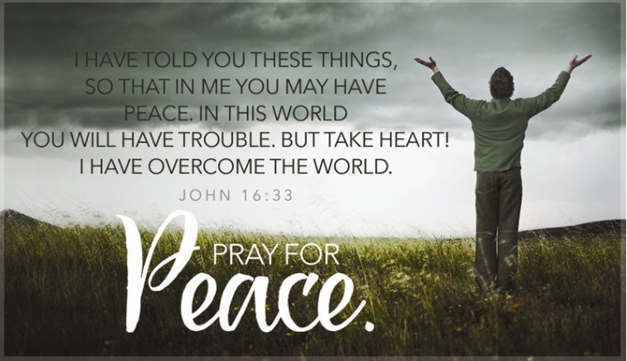

If we decide to act like those who do not believe in God’s word; then we will suffer the benefits of untruth that being disease, instability, anxiety, and doom. God desires us to be full of joy, abundance, and peace so let His word be the directive for your life: Isaiah 55:12 New International Version (NIV), “You will go out in joy and be led forth in peace; the mountains and hills will burst into song before you, and all the trees of the field will clap their hands.”

Next, when we dwell in peace, we will maintain a positive attitude and mindset. As we explore this next level in the progress of abiding in peace, it is key that we focus on God’s word to build our faith in this arena. Some powerful keys to live a life of peace can be unveiled through reviewing a CBN article and meditating on the suggested scriptures below.
SCRIPTURES FOR STUDY:
Psalm 23:1-6 -- A portrait of peace
John 14:1-27; Ephesians 2:14-22 -- Establishing peace in Jesus
Romans 8:6; Ephesians 4:1-3 -- Peace in the Holy Spirit
Mike Bennett shares in his online article that there is a way that humans have consistently strived to live in peace and provides some insight in his article to this thought process. Proverbs 16:7 states that when a man decides to live peacefully, and this is his main thought focus, even his enemies will be convinced to interact in a peaceful manner.


We must master what we think upon to truly walk in peace. Our mind is a powerful weapon, we can create and destroy by what we think upon. Therefore, let’s think on pure, holy, good, and peaceful thoughts. This is one of God’s directives: Philippians 4:8 King James Version (KJV), “ Finally, brethren, whatsoever things are true, whatsoever things are honest, whatsoever things are just, whatsoever things are pure, whatsoever things are lovely, whatsoever things are of good report; if there be any virtue, and if there be any praise, think on these things.” Again, it is vital what we dwell upon and concentrate on peaceful thoughts so that we can thrive in our lives. Isaiah 26:3 King James Bible (KJV), “Thou wilt keep him in perfect peace, whose mind is stayed on thee: because he trusteth in thee.” Oswald Chambers, put it this way that if our mind is not steadfastly dwelling on God’s word and ways, we give our body fatigue and eventually starve it into a nothingness. Therefore, let’s not starve our mind and our life from the blessing of peace, abundance, and prosperity. Although we have not achieved perfection in these earthly bodies yet, we can rest assured that perfected peace from God is a noble pursuit. We can achieve perfect peace if our mind is stayed upon God. Tom Steward dives into how Isaiah 26:3 becomes a rhema word for our life and how we can move into Perfect Peace.

As we continue to explore the benefits of peace, Hope, can be revived and enjoyed. It is time for humans to renew their faith in God. Hope when loss quickly thrust a person into depression, melancholy, and stagnation. Without hope, a person starts to get a victim mentality and then walls are built that eventually imprisons them from living a fully peaceful, joyful, and fulfilling life. The key to hope is redemption from drudgery. Deliverance is found only though acceptance of God’s plan for our life – that is Jesus who is the Hope of Glory. Without Jesus there is no peace, so exploring God’s word on why Jesus brings us into peace and hope is necessary. Everyone has sinned and come short of God’s glory, this is inevitable. Therefore, the avenue to God must be followed so that eternal life can be achieved. Wicked deception is all around and this causes a person to remain hopeless, Isaiah 48:22, “There is no peace, said the LORD, to the wicked.”
When we turn the corner of devastation, to bring us into Hope and peace, we can start to fortify and build harmonious relationships. Again, making sure to build a solid foundation based on God’s word is the ultimate task at hand. Know that peace is a wonderful virtue to possess. This peace spills over into all other interactions that we have in our life. If we are known as a peacemaker this is a talent and skill few can boast. The art of negotiations, have build successful businesses, and productive communities; so, let us continue to pursue peace as a guiding principle for our human connections. Remember stress can kill a body, but it can also destroy meaningful relationships. Therefore, be diligent to strive for peace in all of life’s interactions. There are life skills that we can embrace that will aid in our mastery of living a life of peace. When we are contentious it seeps into all our decisions and creates chaos as well as turmoil. T.R.U.S.T. is not toxic and peace exudes tranquility. This type of living is attractive and productive. Now, it is inevitable that challenges occur whether at home and at work, but when you maintain a peaceful attitude and spirit those obstacles can be negated. One author shares in an online article that peace can be a great benefit in your work environment. Honey is better than vinegar. So, peace is more desired than poison and pain. God provides instructions in his word for building healthy relationships like in Colossians 3:12-13. Another building block for creating strong relationships is not only concentrating on remaining in peace but communicating peace. 1 Peter 3:8-12 provides a framework for how we can communicate further and develop peace that is a positive parameter for human interactions. Remember the meek and peaceful do inherit the earth. Mathew 5:5 is one of the beatitudes that underscores how meekness is a benefit to winning over others in this earth. It is better to be kind, humble, and peaceful when interacting in a social setting. This peaceful attitude in no way connotes a weakness, but emphasizes how strong one is to control emotions that can often derail productive and positive life goals. Peace is one way that we can realize God’s desire for us to be a blessed people.
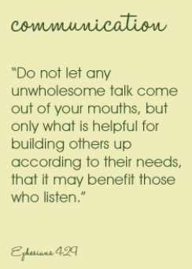
Our environment whether at work or home can improve when we operate in a manner of peace. God is the author and finisher of our faith and He created us in His image. Therefore, as one who exemplifies His precepts we need to be mindful of his tenets for keeping our peace – especially in a work environment - "I give you peace, the kind of peace only I can give. It isn't like the peace this world can give. So don't be worried or afraid." --John 14:27 (CEV). Work life balance can be hard to achieve especially when we are not rooted in God’s word. Remember God desires us to live a life that is full of joy and peace not one that is depressing and bleak. Nicholas Hemming provides Six scriptures that can restore our peace when we engage in a pressure packed work environment:
These six verses will get you started.
- The Lord gives rest.
Come to me, all of you who are tired from carrying heavy loads, and I will give you rest. Take my yoke and put it on you, and learn from me, because I am gentle and humble in spirit; and you will find rest. For the yoke I will give you is easy, and the load I will put on you is light. – Matthew 11:28-30 (GNTD)
- The Lord gives strength.
But those who trust in the Lord for help will find their strength renewed. They will rise on wings like eagles; they will run and not get weary; they will walk and not grow weak.– Isaiah 40:31 (GNTD)
- The Lord gives peace.
You, Lord, give perfect peace to those who keep their purpose firm and put their trust in you. – Isaiah 26:3 (GNTD)
- The Lord gives hope.
May God, the source of hope, fill you with all joy and peace by means of your faith in him, so that your hope will continue to grow by the power of the Holy Spirit. – Romans 15:13 (GNTD)
- The Lord gives wisdom.
But if any of you lack wisdom, you should pray to God, who will give it to you; because God gives generously and graciously to all. – James 1:5 (GNTD)
- The Lord gives guidance.
The Lord says, “I will teach you the way you should go; I will instruct you and advise you. – Psalm 32:8 (GNTD)

Next, when looking at how peace helps us internally and externally, one can elevate their creativity when operating from a posture of peace. Ngozi shares reasoning of why peace aid creativity:

“Creativity – Peace enables one to be creative. The mind is restful, not crowded with worries and negative thoughts. A Peaceful mind is observant and very attentive. Ideas are quick to settle on a calm mind.”

Mona Shah Joshi provides some context on how peace carves out a better world where inroads to creative thought processes, positive race relations, and spreading humane acts of kindness is to be desired. Another blogger named Diana prescribes to how creativity can be found when one taps into their inner peace. Watkins also supports that inner peace breeds creative exploits, “Inner peace is both the foundation and the sustenance of creative and beautiful thinking. Occasionally inspirational thought can be ‘triggered’ by cruel or angry intentions, but a steady flow of insight and inspiration is guaranteed when the mind is quiet and peaceful.”

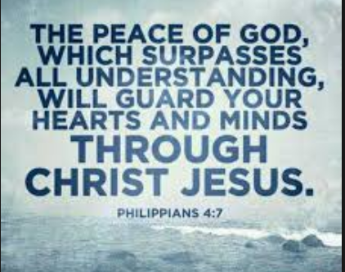

I, personally have created inspirational messages while my surroundings were full of upheaval because I was able to reside in the peace of God that surpassed by own understanding. The Thankful Revolution was birthed while I endured life’s roadblocks. My life’s surroundings were not optimal, but God’s peace lay in my soul to quiet me into a state of confidence that God would never leave me nor forsake me. This is the joy, the wonder, the awe, the blessing, the greatness that shines through all darkness and sparks creation into reality where once a void existed. In the beginning, God created all that currently exists so yes when there is a darkness one can find supreme peace to allow glory to become visible.

Another area that peace will alter is how satisfied and content you become as a person. When we dwell in doubt this creates a cavern of chaos in our life. It is unsettling to always be anxious and never be liberated from that kind of bondage. Peace allows our mind to be settled and our decisions to become purposeful. James 1:8 King James Version (KJV), “A double minded man is unstable in all his ways.” Jon Bloom penned an online article that scripturally supports how peace provides stability, contentment, and satisfaction. One may think that Christians possess secret and hidden insight into how to abide in the realm of peace. This is not the case, but what is a plausible statement is that God desires everyone to enjoy the fruit of living in peace. Jon further provides ways that people can abound as those who enjoy peace. Bloom shares the following scriptures as foundations for this type of peaceful existence.

Trusting God is the secret:
To forgiving those who have sinned against us (Ephesians 4:32).
To turning away from sexual temptation (1 Thessalonians 4:3).
To giving generously to kingdom needs, even beyond your means (2 Corinthians 8:3).
To not allowing material abundance to choke the word in us (Matthew 13:22).
To rejoicing even when sorrowful (2 Corinthians 6:10).
To contentment even when experiencing deprivation (Philippians 4:12).
To boldness even in the face of fearful threats (Acts 4:29).
To peace even when facing pressured trials (Philippians 4:6–7).
To joy even when enduring withering affliction and illness (2 Corinthians 1:3–5).
To hope when all around our soul gives way (Psalm 42:11).
To gracious patience under pressured labors (Colossians 1:11).
To blessing those who persecute us (Romans 12:14).
To courage in leaving family and property for Jesus’s sake (Matthew 19:29).
To overcoming discouragement due to adversity and weakness (2 Corinthians 12:10).
To not allowing indwelling sin to reign over or condemn us (Romans 6:12, 8:1).
To loving saints who sin and sinful unbelievers (John 15:12; Romans 12:10; Romans 9:1–3).
To facing every other fear and anxiety-producing temptation.
God promises to give us peace and contentment if we trust him (Philippians 4:6–7). He really wants us to experience them in increasing measure, even here in this troubled world (John 16:33).
Finally, a person who remains in peace embodies a life full of the Favour from God. The word of God assures how grace and peace is provided to us, Philippians 1:2 King James Bible (KJV), “Grace be unto you, and peace, from God our Father, and from the Lord Jesus Christ.” God’s word provides a prayer declaration for favour and peace in Ephesians 1:2 (Amplified Bible): “May grace (God’s unmerited favor) and spiritual peace (which means peace with God and harmony, unity, and undisturbedness) be yours from God our Father and from the Lord Jesus Christ.” To continue this indelible stamp of God’s word that peace and favour brings tremendous victory as citizens of Heaven is more from God’s word:

2 Peter 1:2-4 Amplified Bible, Classic Edition (AMPC)
² May grace (God’s favor) and peace (which is ^{[a]}perfect well-being, all necessary good, all spiritual prosperity, :and ^{[b]}freedom from fears and agitating passions and moral conflicts) be multiplied to you in [the full, personal, ^{[c]}precise, and correct] knowledge of God and of Jesus our Lord.
³ For His divine power has bestowed upon us all things that [are requisite and suited] to life and godliness, through the [^{[d]}full, personal] knowledge of Him Who called us by and to His own glory and excellence (virtue).
⁴ By means of these He has bestowed on us His precious and exceedingly great promises, so that through them you may escape [by flight] from the moral decay (rottenness and corruption) that is in the world because of covetousness (lust and greed), and become sharers (partakers) of the divine nature.
God’s desire is for us to relish in His unending goodness and mercy for our lives. He created us in His image to enjoy a life and that life more abundant. We are called to dominate over the angst of life. God spoke our lives into existence to be fulfilled with blessings and prosperity. His word continues to support this line of thought, in Jeremiah 29:11 it shares His promise to us,
“ For I know the thoughts that I think toward you, says the Lord, thoughts of peace and not of evil, to give you a future and a hope.” Derek Hill provides additional insight on scriptures with commentary on how we can remain in a contented peace as we explore this journey called life. It doesn’t matter where we are in this life, God will always protect and promote his favour towards us. We need to remember that His desire is for us to be whole. Additional scriptures for us to know more about contentment and peace can be found in the hope, faith, and prayer online blog. Psalm 23:5–6, “You prepare a table before me in the presence of my enemies; You anoint my head with oil; my cup runs over. Surely goodness and mercy shall follow me all the days of my life; and I will dwell in the house of the Lord forever.”
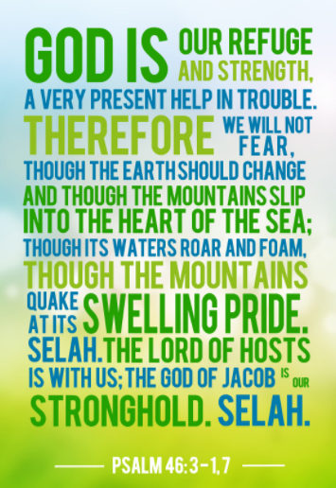

Continue to absorb God’s word and explore how peace brings you into your purpose. Meditate day and night on God’s truth. Study to show yourself as a wise person as you journey along your pathway to fulfilled vision and dreams. Selah and Shalom

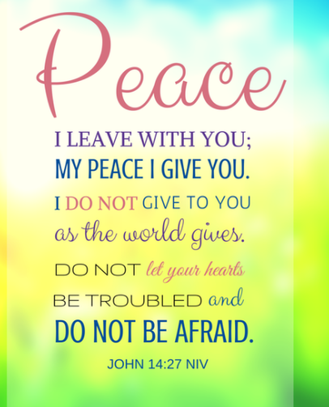

Study Bible – Scriptures to live by while pursuing your posture of peace:
A Call to Holiness
13Make straight paths for your feet, so that the lame will not be debilitated, but rather healed. 14Pursue peace with all men, as well as holiness,without which no one will see the Lord. 15Be careful that no one falls short of the grace of God, so that no root of bitterness will spring up to cause trouble and defile many.…
Berean Study Bible · Download
Cross References
Psalm 34:14
Depart from evil and do good; Seek peace and pursue it.
Matthew 5:8
Blessed are the pure in heart, for they will see God.
Romans 6:22
But now that you have been set free from sin and have become slaves to God, the fruit you reap leads to holiness, and the outcome is eternal life.
Romans 14:19
So then, let us pursue what leads to peace and to mutual edification.
Hebrews 9:28
so also Christ was offered once to bear the sins of many; and He will appear a second time, not to bear sin, but to bring salvation to those who eagerly await Him.
Hebrews 12:10
Our fathers disciplined us for a short time as they thought best, but God disciplines us for our good, so that we may share in His holiness.
Treasury of Scripture
Follow peace with all men, and holiness, without which no man shall see the Lord:
Follow.
Genesis 13:7-9 And there was a strife between the herdsmen of Abram's cattle and …
Psalm 34:14 Depart from evil, and do good; seek peace, and pursue it.
Psalm 38:20 They also that render evil for good are my adversaries; because I …
Psalm 120:6 My soul has long dwelled with him that hates peace.
Psalm 133:1 Behold, how good and how pleasant it is for brothers to dwell together in unity!
Proverbs 15:1 A soft answer turns away wrath: but grievous words stir up anger.
Proverbs 16:7 When a man's ways please the LORD, he makes even his enemies to be …
Proverbs 17:14 The beginning of strife is as when one lets out water: therefore …
Isaiah 11:6-9 The wolf also shall dwell with the lamb, and the leopard shall lie …
Matthew 5:9 Blessed are the peacemakers: for they shall be called the children of God.
Mark 9:50 Salt is good: but if the salt have lost his saltiness, with which …
Romans 12:18 If it be possible, as much as lies in you, live peaceably with all men.
Romans 14:19 Let us therefore follow after the things which make for peace, and …
1 Corinthians 1:10 Now I beseech you, brothers, by the name of our Lord Jesus Christ, …
Galatians 5:22,23 But the fruit of the Spirit is love, joy, peace, long-suffering, …
Ephesians 4:1-8 I therefore, the prisoner of the Lord, beseech you that you walk …
1 Thessalonians 5:15 See that none render evil for evil to any man; but ever follow that …
1 Timothy 6:11 But you, O man of God, flee these things; and follow after righteousness, …
2 Timothy 2:22 Flee also youthful lusts: but follow righteousness, faith, charity, …
James 3:17,18 But the wisdom that is from above is first pure, then peaceable, …
1 Peter 3:11 Let him eschew evil, and do good; let him seek peace, and ensue it.
and holiness.
Hebrews 12:10 For they truly for a few days chastened us after their own pleasure; …
Psalm 94:15 But judgment shall return to righteousness: and all the upright in …
Isaiah 51:1 Listen to me, you that follow after righteousness, you that seek …
Luke 1:75 In holiness and righteousness before him, all the days of our life.
Romans 6:22 But now being made free from sin, and become servants to God, you …
2 Corinthians 6:17 Why come out from among them, and be you separate, said the Lord, …
2 Corinthians 7:1 Having therefore these promises, dearly beloved, let us cleanse ourselves …
Philippians 3:12 Not as though I had already attained, either were already perfect: …
1 Thessalonians 3:13 To the end he may establish your hearts blameless in holiness before …
1 Thessalonians 4:7 For God has not called us to uncleanness, but to holiness.
1 Peter 1:15,16 But as he which has called you is holy, so be you holy in all manner …
1 Peter 3:13 And who is he that will harm you, if you be followers of that which is good?
2 Peter 3:11,18 Seeing then that all these things shall be dissolved, what manner …
3 John 1:11 Beloved, follow not that which is evil, but that which is good. He …
no man.
Genesis 32:30 And Jacob called the name of the place Peniel: for I have seen God …
Job 19:26 And though after my skin worms destroy this body, yet in my flesh …
Job 33:26 He shall pray to God, and he will be favorable to him: and he shall …
Matthew 5:8 Blessed are the pure in heart: for they shall see God.
1 Corinthians 13:12 For now we see through a glass, darkly; but then face to face: now …
2 Corinthians 7:1 Having therefore these promises, dearly beloved, let us cleanse ourselves …
Ephesians 5:5 For this you know, that no fornicator, nor unclean person, nor covetous …
Galatians 3:21 Is the law then against the promises of God? God forbid: for if there …
1 John 3:2,3 Beloved, now are we the sons of God, and it does not yet appear what …
Revelation 21:24-27 And the nations of them which are saved shall walk in the light of …
Revelation 22:3,4,11-15 And there shall be no more curse: but the throne of God and of the …

